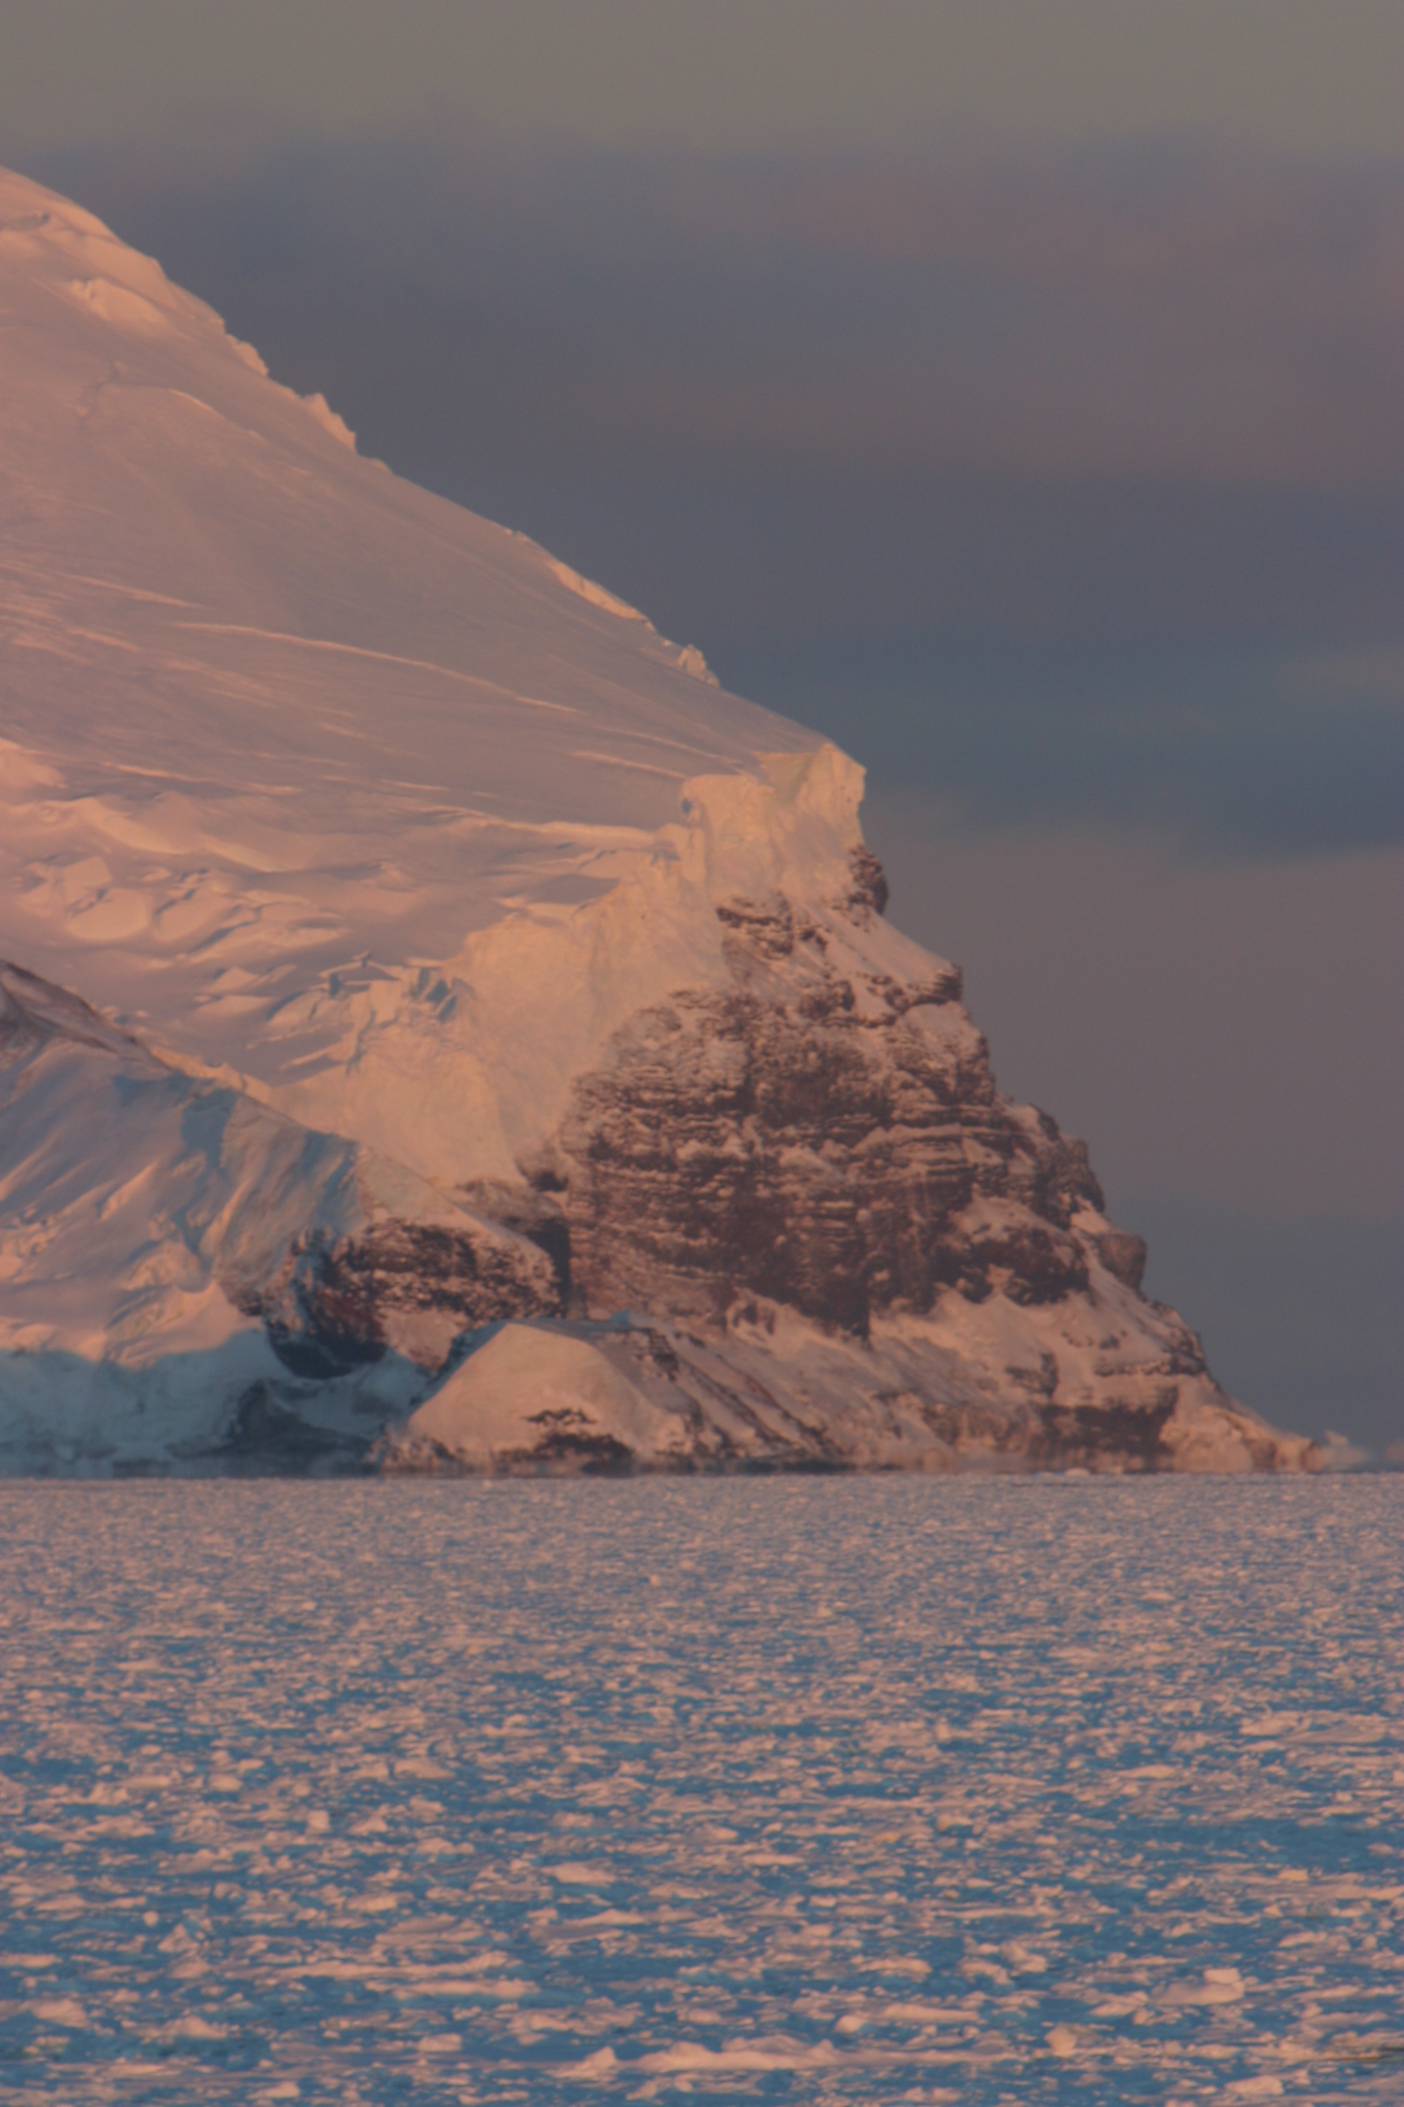
Thank you to all of the following for your photo contributions:

Steve Ackley
Mike Lewis
Blake Weissling
John Pena
Penelope Wagner
Chris Fritsen
Robert Ochoa
Martin VanCoppenolle
Bruno Delille
Nicolaus-Xavier Geilfus
Isabelle Dumont
Florence Masson
Sharon Stammerjohn
Katherine Leonard
Kathleen Gavanah
Keith Johnson

